For Release
June 21, 2023

Decatur Rotary Club Announces Community Grant Awards to Dekalb County Non-Profits to Support Literacy
Decatur Rotary Club 6900 announced monetary grants to Dekalb County community non-profit organizations. The Rotary Club’s focus is for these organizations to use the award within their individual missions to increase literacy thereby positively impacting Dekalb residents and children to become more successful and lead productive lives.

Decatur, Georgia—Historic Dekalb Courthouse, June 21, 2023: The Rotary Club of Decatur, GA announced its annual community grants for non-profits of Dekalb County to support literacy in the community in its meeting at the historic Dekalb Courthouse in Decatur on June 16. At the meeting, checks were awarded and representatives from each organization spoke on how they will use the grant to improve literacy.

Dan DeWoskin, Decatur Rotary Foundation Chair, hosted the event, welcomed representatives from each non-profit and provided checks to support their work to improve literacy.

The Rotary Club of Decatur actively supports Rotary International’s initiative to increase literacy and education worldwide. According to Rotary International, more than 775 million people over the age of 15 are illiterate. That’s 17 percent of the world’s adult population. Our goal is to strengthen the capacity of communities to support basic education and literacy, reduce gender disparity in education, and increase adult literacy. We support education for all children and literacy for children and adults.

Organizations and their representatives receiving grants included:
- Creating Our Future: Brittany Moore-Hill
- Dekalb Library Foundation, Elisabeth Nark
- Decatur Makers, Kalia Morrison
- Decatur YMCA, Stacey Stevens & Beth Costello
- Family Heritage Foundation, Bennett Ekandem
- Literacy Action, Sara Totonchi
- Friends of Refugees
- Our House, Stephanie Lloyd
- Men Stopping Violence, Mark Bracey
“Rotary’s mission is helping organizations in our community. The organizations selected for awards truly understand and actively embrace the concept of improving literacy within their own individual missions to help uplift the people they serve.” said Rotary Member and Chair of the Community Grant Program, Mr. Daniel DeWoskin.
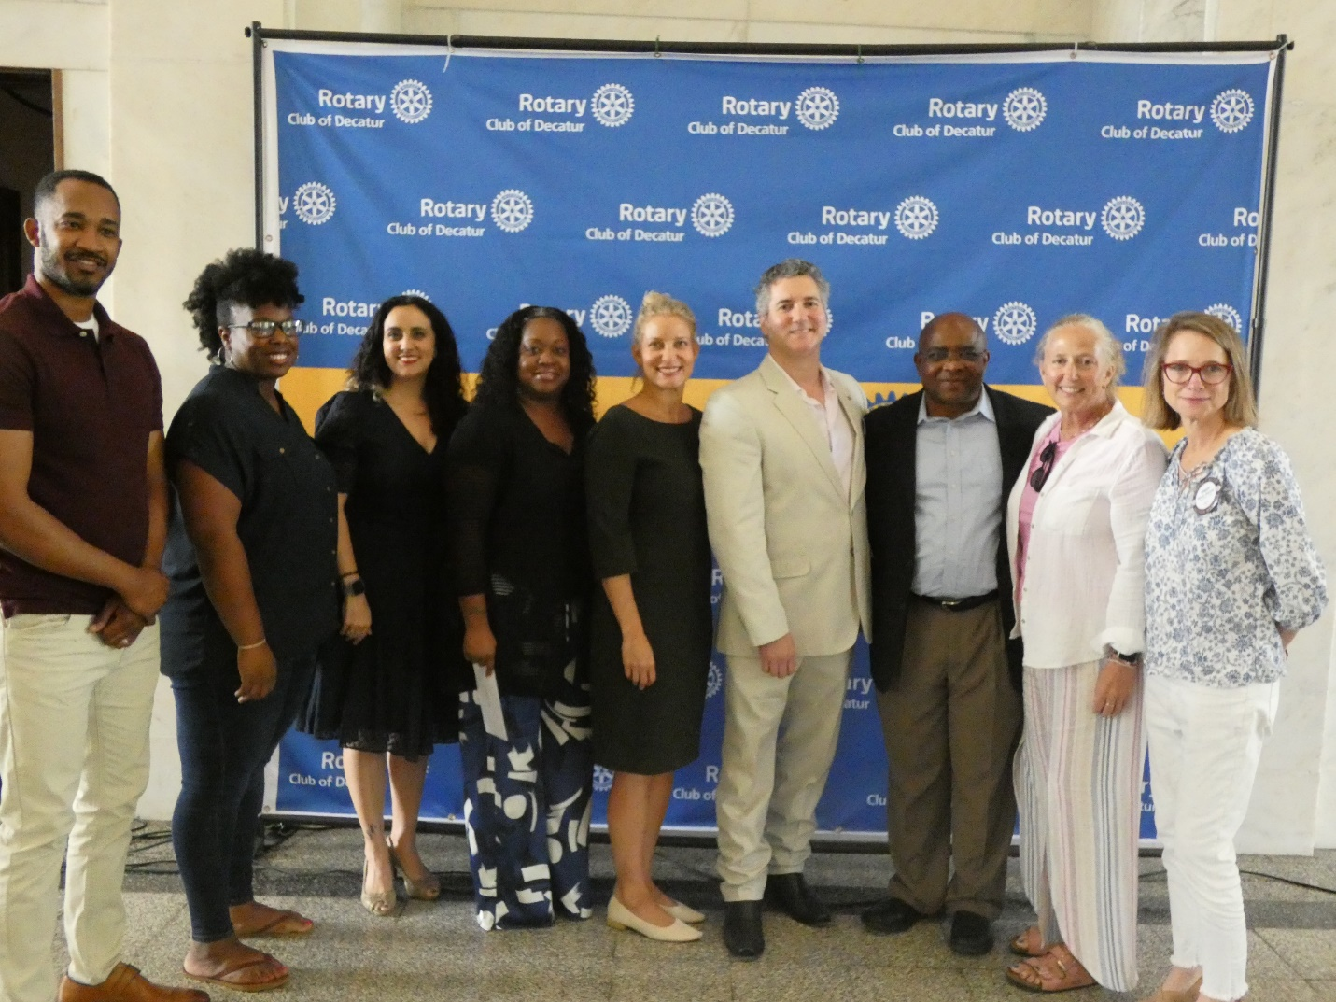

About the Rotary Club of Decatur, GA
The Rotary Club of Decatur has grown from its humble origins in 1938 with its original membership of 19 members to over 100 today. Decatur Rotary is a diverse group of business, community, and local government leaders. Inclusion and diversity are at the core of the Decatur Rotary Club. The Club meets in the historic Decatur Courthouse which is home to the Dekalb History Center. Decatur Rotarians gather each Friday at 12:15 PM.
###
For More Information:

Dudley Larus, Rotary Club of Decatur Communications
678-863-4239
dudleylarus@gmail.com

